Gun Smiths week specials for February 2 thru 7 2026 or while supplies last

RADICAL FIREARMS FR16-5.56SOC-15RPR-B5 AR RIFLE 5.56 16" BBL 30RD
Item Number: GRF00028
UPC: 816903022823
$ 399.99
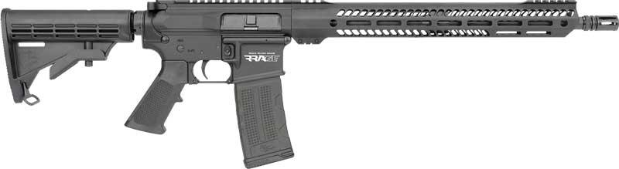
MOSSBERG 990 SPX AFTERSHOCK 12GA 3" 14.75" 6RD MATTE
Item Number: G83010
UPC: 015813830102
$899.99
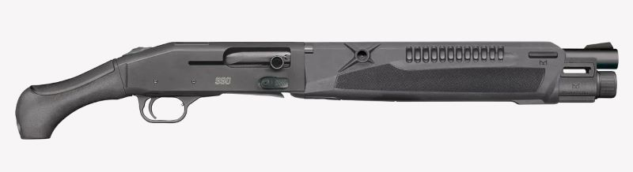
RADICAL FIREARMS FP10 5-56M4-10RPR AR PISTOL 5.56 10.5" BBL BLACK
Item Number: GRF00139
UPC: 816903022434
$399.99
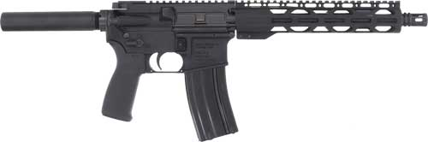

ZASTAVA ZPAPM70 BATTLE WORN RIFLE 7.62X39 30RD WALNUT
Item Number: GZAZR7762FL
UPC: 685757098816
$1,200
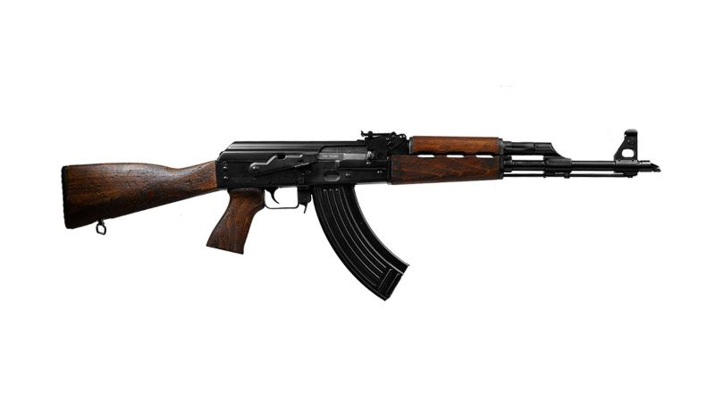
SPRINGFIELD HELLCAT OSP 9MM 3" 11/13RD 4 MAGS GEAR PACK
Item Number: G9319BOSPPAC
UPC: 706397999629
$599.99

